1) Retrieve all books in the "Fiction" genre:

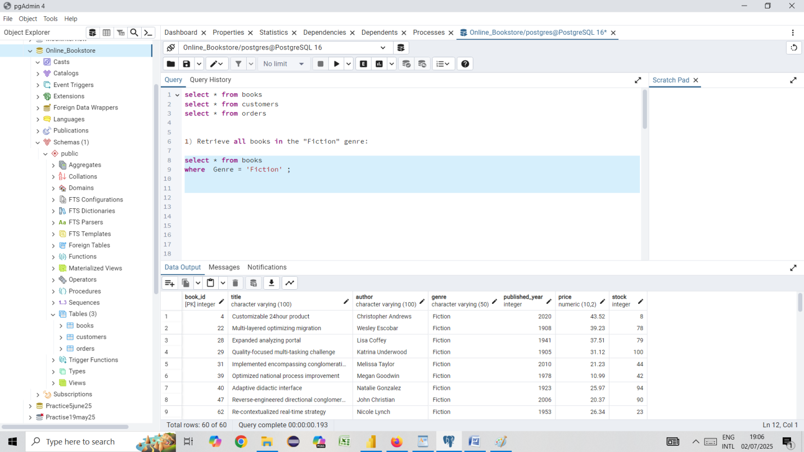

2) Find books published after the year 1950:

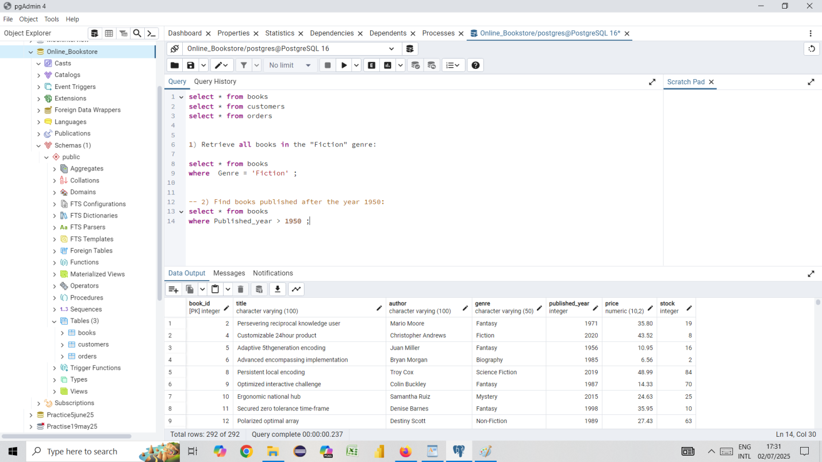

3) List all customers from the Canada:

)

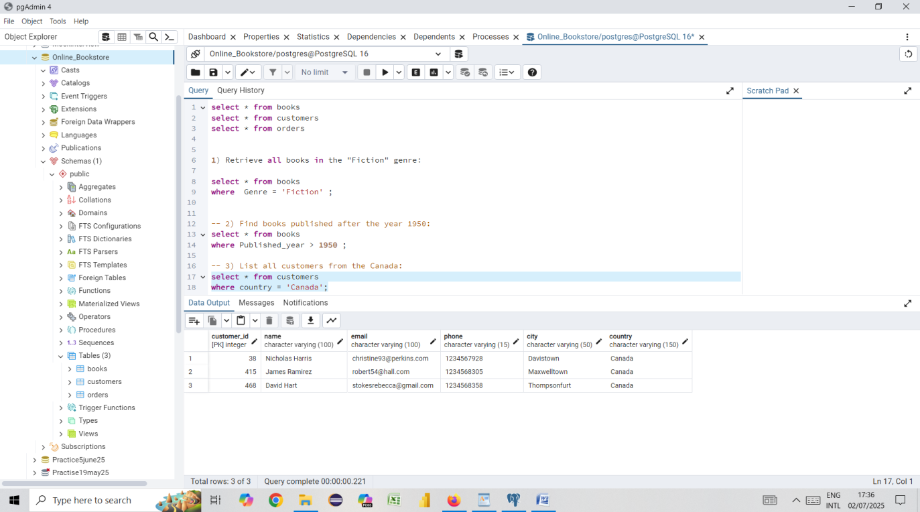

4. Show orders placed in November 2023:

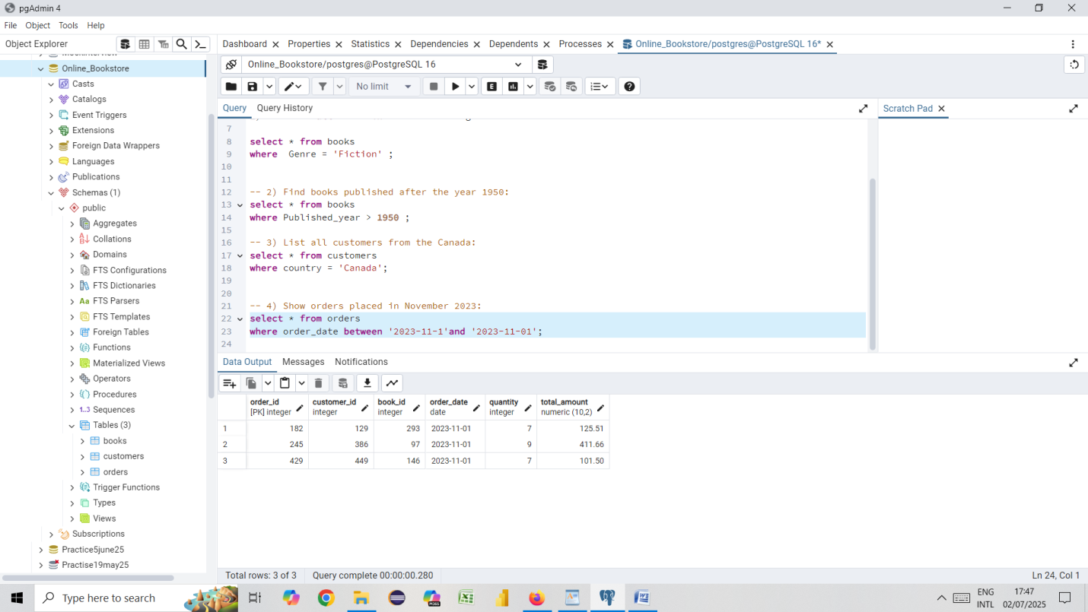

5) Retrieve the total stock of books available:

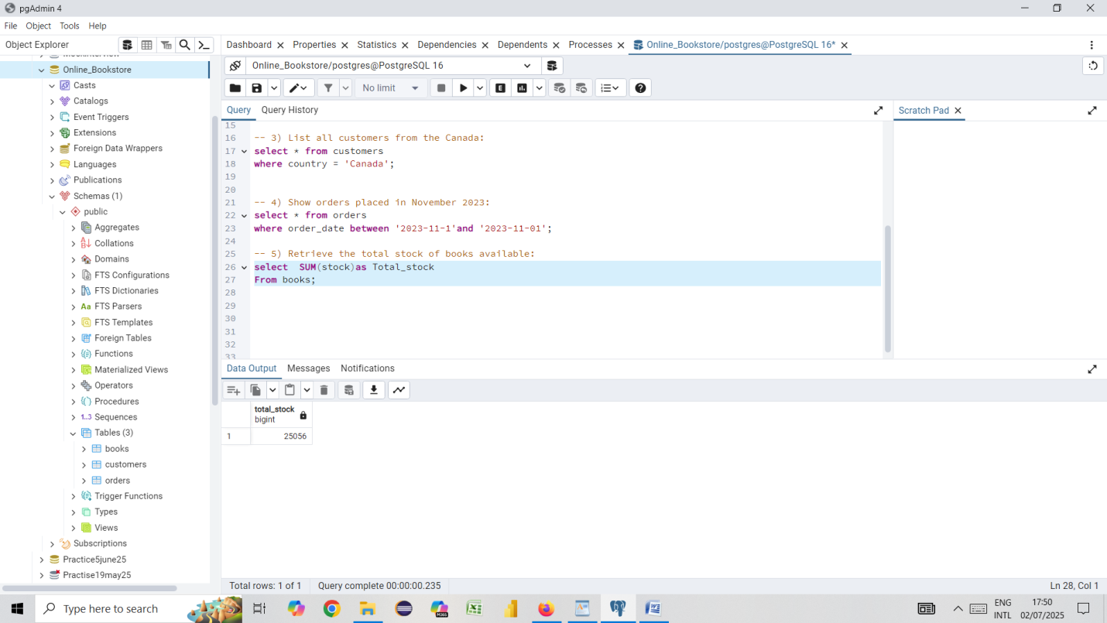

6) Find the details of the most expensive book:

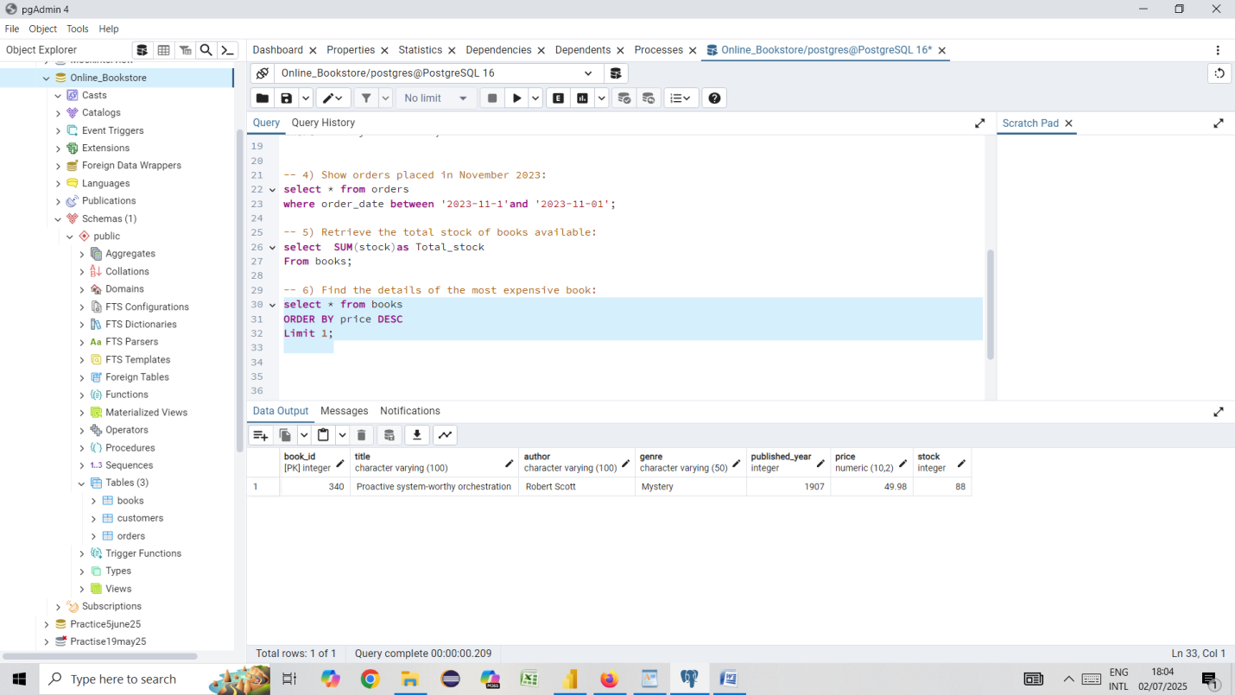

7) Show all customers who ordered more than 1 quantity of a book:

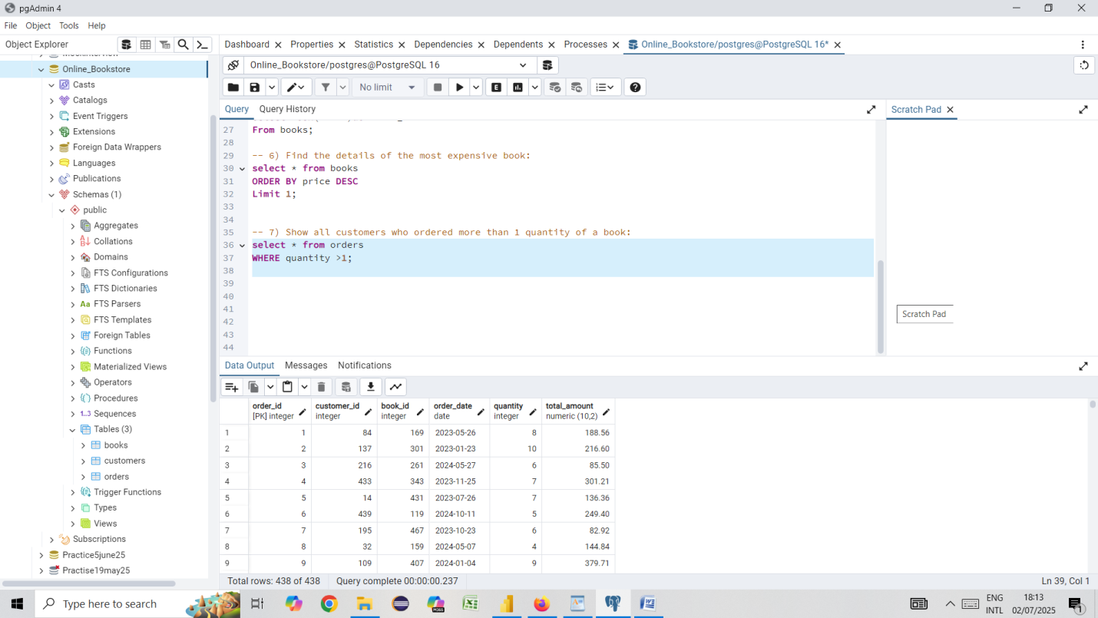

8) Retrieve all orders where the total amount exceeds $20:

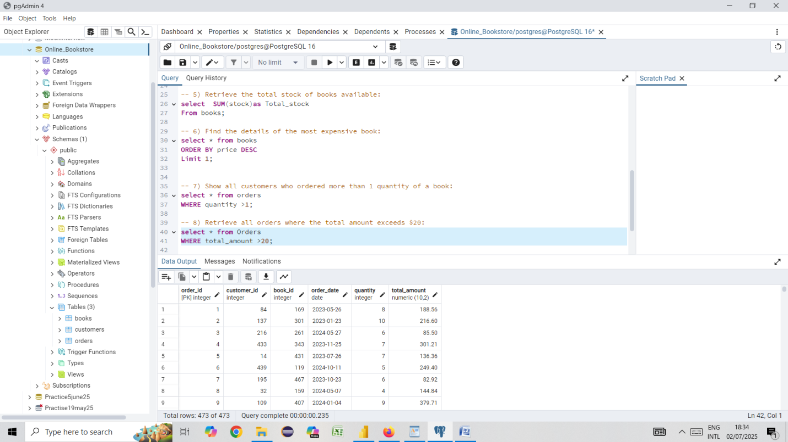

9) List all genres available in the Books table:

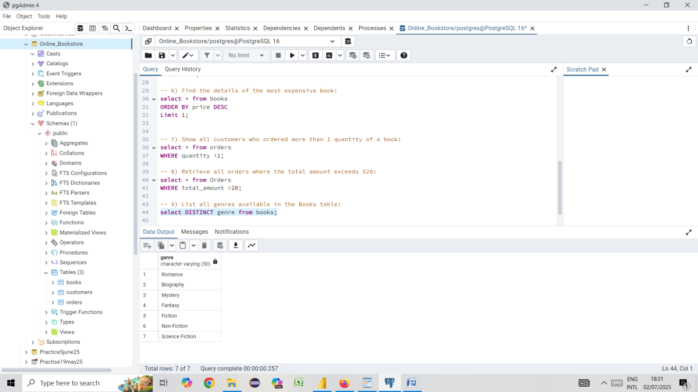

10) Find the book with the lowest stock:

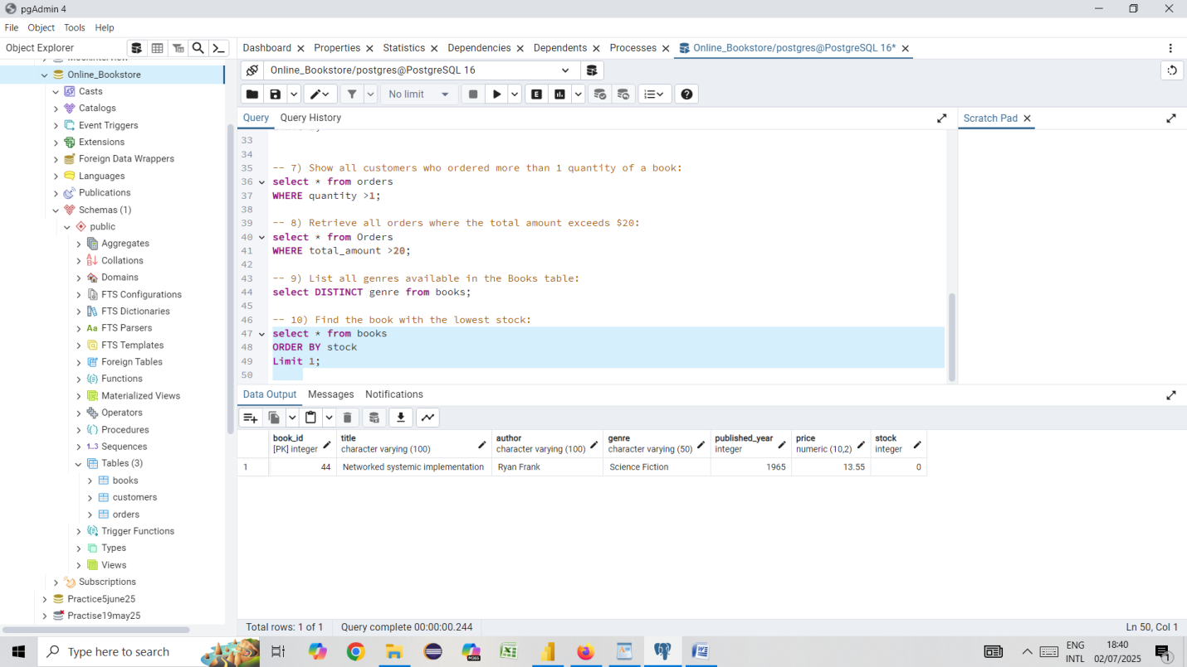

11) Calculate the total revenue generated from all orders:

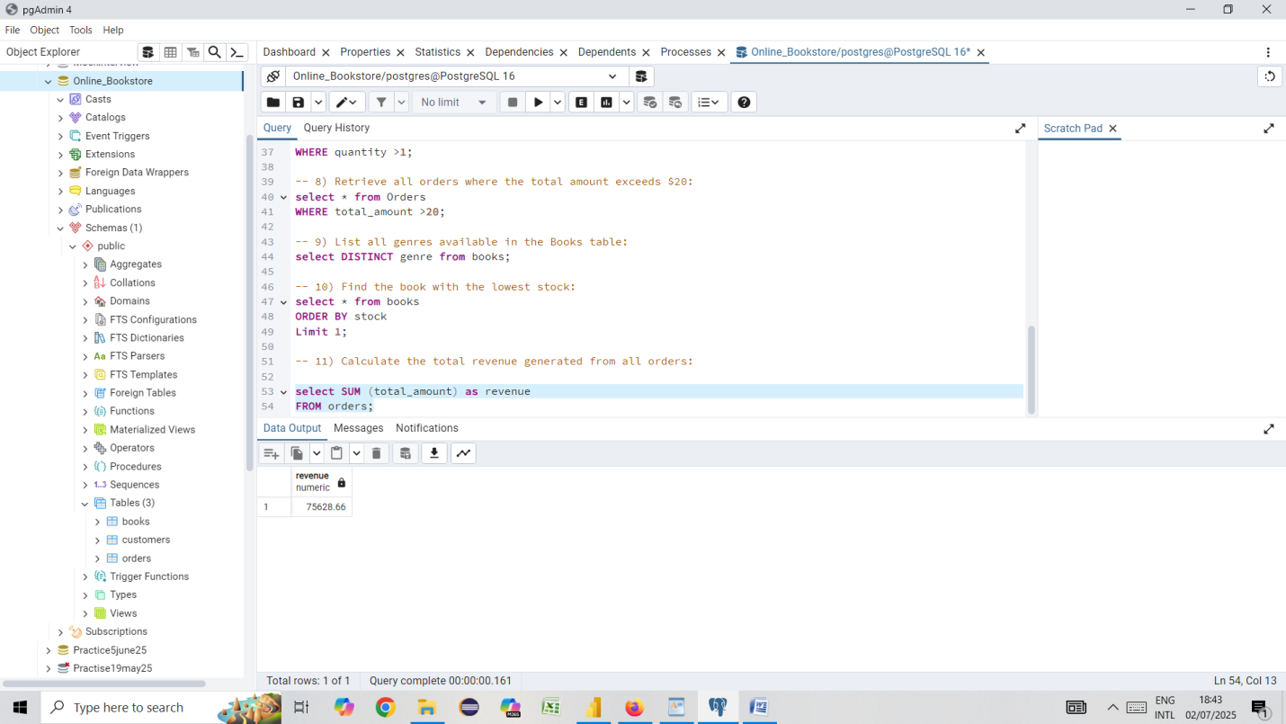

12) Retrieve the total number of books sold for each genre:

